Current Drivers Rev. D
Control Loop Compensation Adjustment

Don Straney
dstraney@mgh.harvard.edu
2021-07-08

Instructions
- Measure the inductance and series resistance of your coil, including all cabling, using an LCR meter such as the Keysight U1733C. 100 kHz (or 10 kHz if your LCR meter doesn’t reach 100 kHz) is the preferred measurement frequency, as this is in the general range of where the control loop crossover will be.
- Open “compensation.m” and change the values next to “Rload” and “Lload” to match your measured coil parameters.
- If you are using MATLAB instead of GNU Octave, comment the “pkg load control” line.
- Save and close, then run the script in MATLAB or Octave. It should produce two figures, one showing the loop frequency response and one with step response, and output text describing the component values. This is the sample output for a 723µH + 10Ω coil:

Rin total value: 108.5 ohms
Rin value to install: 8.5 ohms (closest E24 is 8.2 ohms, error of 0.3%)
Cfbk total value: 1313 pF
Cfbk value to install: 1293 pF (closest E12 is 1200 pF, error of 7.1%)
Max. load capacitance across coil: 265 pF
------------
Phase margin: 67.1 degrees @ 36360 Hz crossover
Gain margin: 19.1 dB @ 213732 Hz
------------
Min. Rin value, constrained by error amplifier BW: 108.5 ohms
Load pole: 2245.34 Hz
Error amplifier zero: 6062.42 Hz
Error amplifier GBP pole: 238797 Hz
Predicted parasitic PCB-feedback-capacitance pole: 3.97887e+06 Hz
Vout_cmd filter pole: 4.97359e+06 Hz
------------
1% settling time: 6.51e-05 s
0.1% settling time: 1.18e-04 s
1% settling time with LPF: 7.69e-05 s
0.1% settling time with LPF: 9.87e-05 s

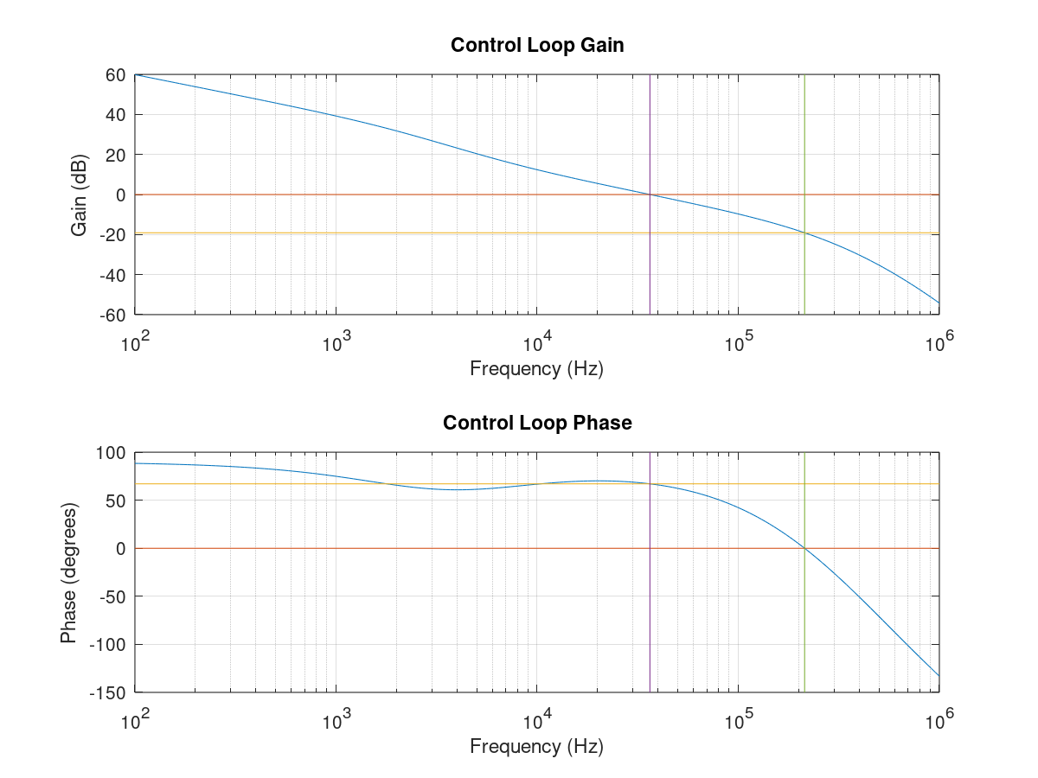
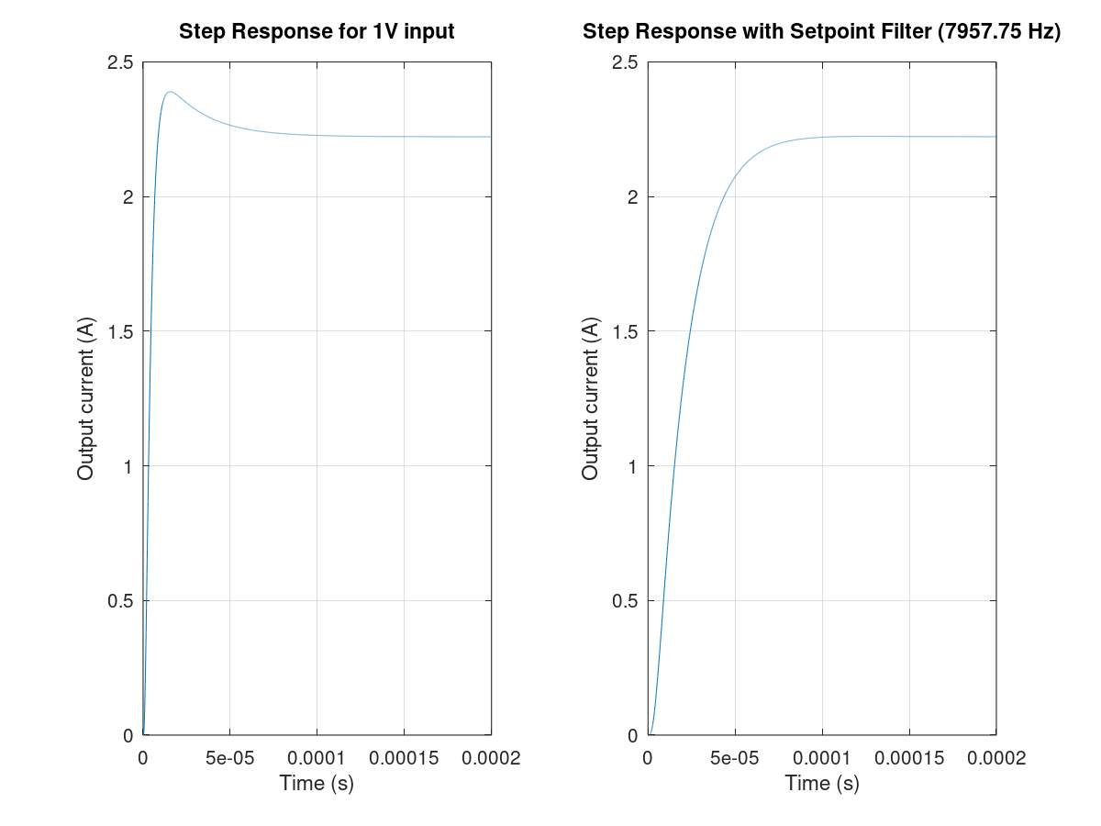

Using the Results
Compensation components: There are two components you will need to install for every channel: one resistor (“Rin”) and one capacitor (“Cfbk”), with the values given here (“closest E12…” and “closest E24…”). You will need to have through-hole components with these values; for the capacitor, use 50V NP0/C0G ceramic parts with a 0.1”/2.54 mm lead spacing, and for the resistor, use a metal film (not carbon composition) 1/8W / 0204-size part for easiest insertion.
If the Cfbk value to install is < 10 pF, don’t install a capacitor. If the Rin value to install is < 5Ω, install a jumper instead (U-shaped piece of 24-26 AWG solid bare wire). Fold one of the resistor leads back over the body. Trim all leads to ~1 cm maximum away from the body.
Insert these components into the labeled sets of holes in the amp control board, from the top (outward-facing) side:
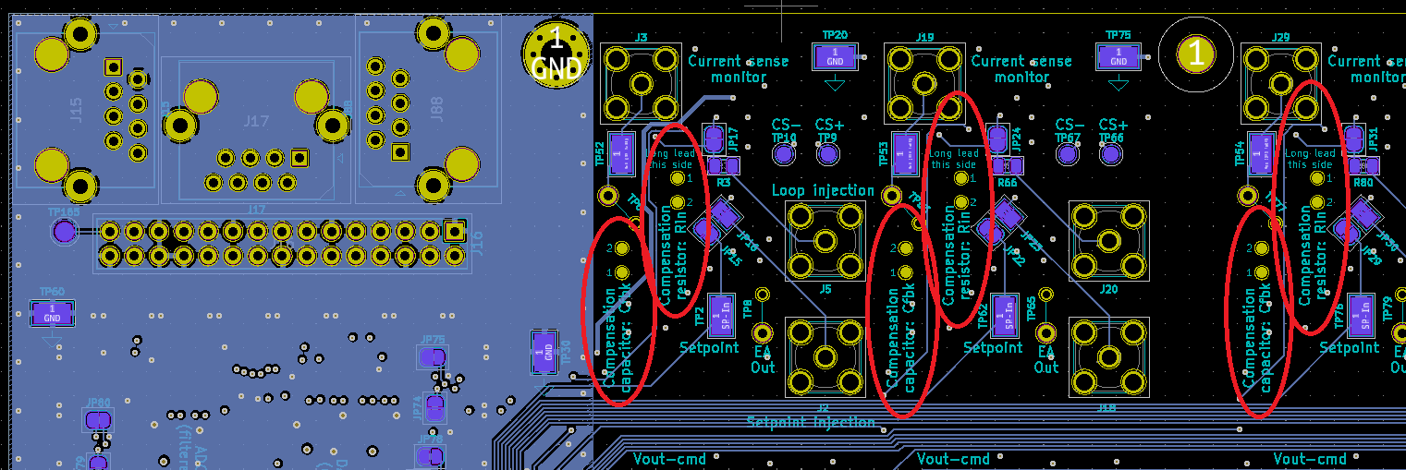
Make sure to insert the resistor in the orientation described, with the longer lead facing the edge of the board and the body facing the interior of the board. This orientation puts less conductor area on the inverting node of the error amplifier and potentially reduces destabilizing parasitic capacitance and coupling from other channels/noise sources.

Capacitance across coil: Shim coils will often have one or more filter capacitors placed across their leads at some point in the cabling, either to prevent transmitted RF from traveling out of the scanner’s bore along the shim cables, or to prevent RF noise outside the scanner from travelling into the bore along the shim cables. The maximum value of this capacitance is limited in practice by the resonance it creates with the shim coil’s inductance, which causes various effects that erode the gain margin and therefore stability of the control loop. The compensation script makes a general prediction of the maximum coil capacitance allowed, and prints it as “Max. load capacitance across coil” (265 pF in the example above). Do not use more than this total allowed capacitance (including feed-through filters, multiple capacitors, etc.) across your shim coil.

Settling time: The “settling time” values printed show how long it will take after each change of output current setpoint (not including the delay for digital communications) for the output current to settle to within either 1% or 0.1% of the final value.

Slew-Rate Limiting
Some applications will want to limit the slew rate when changing the output current, to reduce the movement and auditory noise created by the force on the coil in the scanner’s magnetic field. This is best handled by software, but if for various reasons a hardware low-pass filter (LPF) is needed on the current setpoint, the effect on the step response can be predicted by the compensation script.
The “Rsplpf” and “Csplpf” variables in “compensation.m” set the parameters for a single-pole RC filter. When “compensation.m” is run, the right-most step response plot (titled “...with Setpoint Filter”) will show the modified step response with the LPF present. The second set of settling times printed (“...with LPF:”) shows the settling times with the LPF present.

